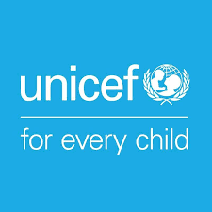

How to work with children and adults with disabilities during Covid-19 and make sure they have a say

Covid-19 is a new illness that many people in the world are getting. It is also called coronavirus.

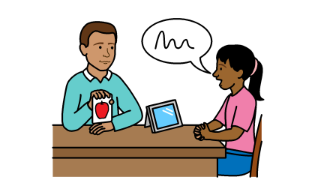

Risk Communication and Community Engagement for COVID-19 – Engaging with Children and Adults with Disabilities

About us

We are called Unicef.

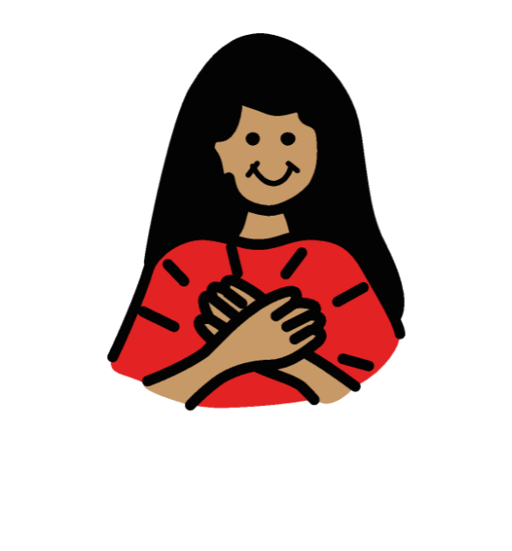

We work to make sure that all children in the world are safe and treated fairly.

About this document

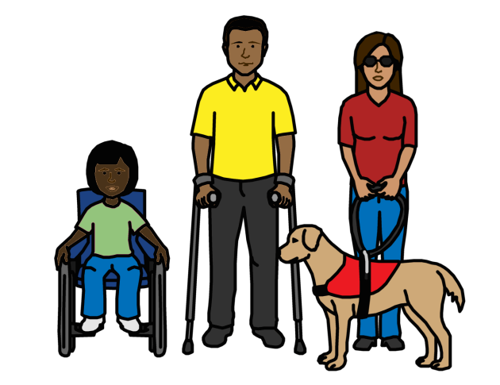
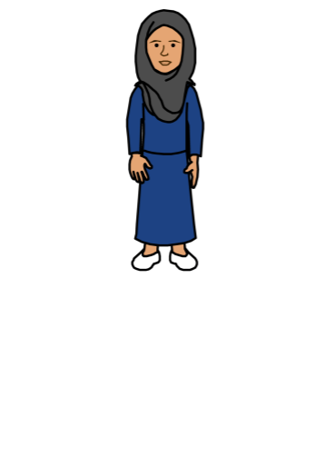
This document is about children and adults with disabilities.

It is about how to work with them while Covid-19 is happening.

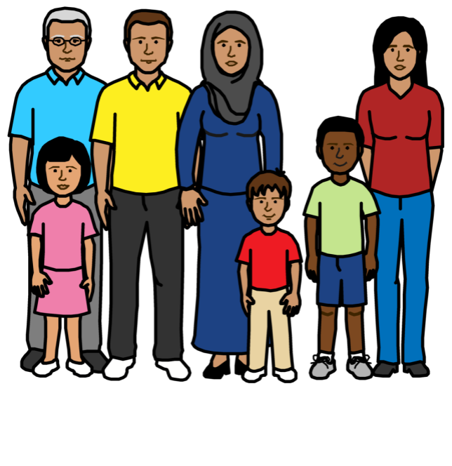
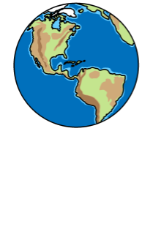
Covid-19 is also called coronavirus.

It is a new illness. Many people in the world are getting it.

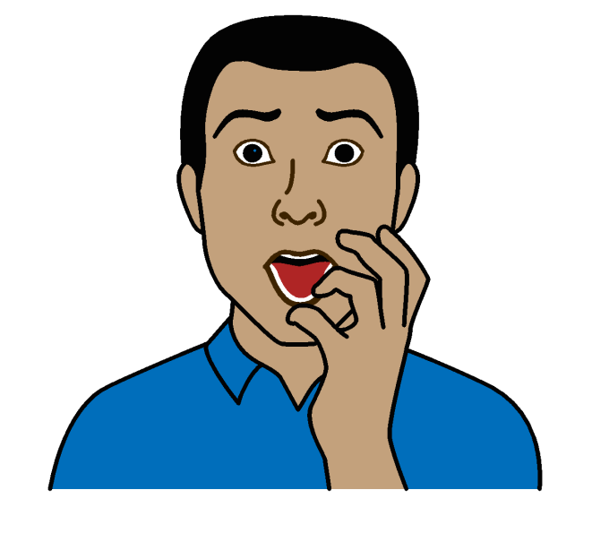

Some people with disabilities might be in more danger because of Covid-19.

This document is about how to work with children and adults with disabilities to make sure:
- They are safe and get what they need

- They can help with plans about Covid-19

Anyone can use this document.

For example:
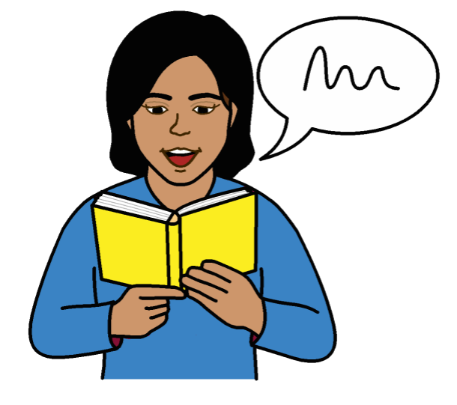
- People with disabilities and disability groups

- Parents and other people in the community

- Governments and people who work for Unicef and other organizations

How to work with children and adults with disabilities during Covid-19

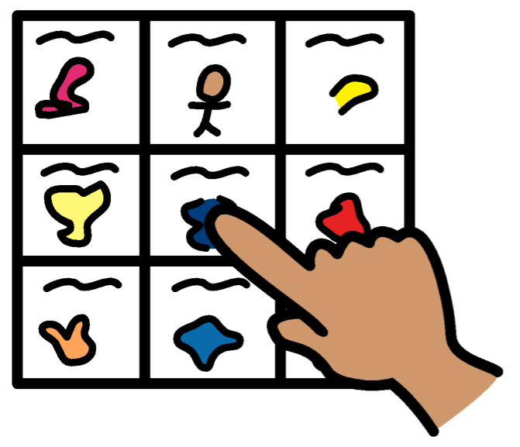
1.

Make sure people with disabilities get information they can understand about Covid-19, how to keep safe and where to get support

This means giving people with disabilities information in different ways.

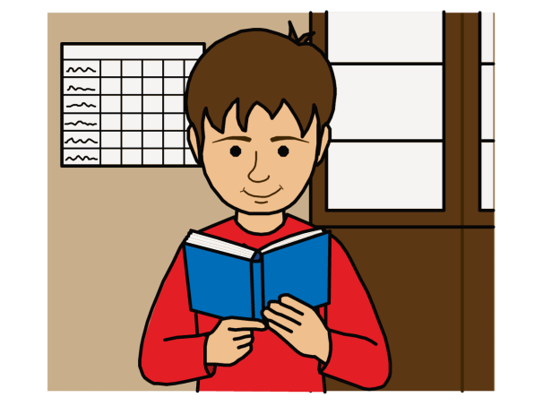
For example:

- Braille and large writing for people who find it hard to see

- Information with easy words and pictures for people who find it hard to read

- Video with words on the screen or sign language for people who find it hard to hear

- Websites that are easy for people with disabilities to use
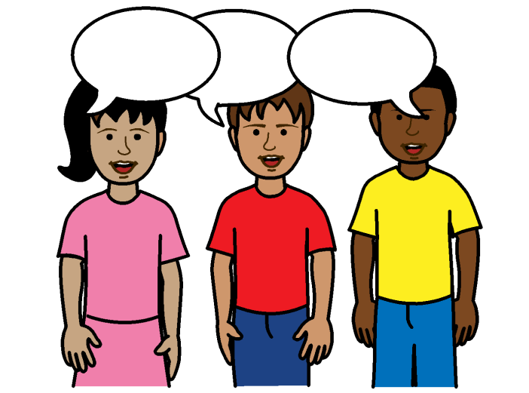
Information like this can also help other people.
For example:
- Children and young people
- People who speak other languages

It is important for people in the community to know:
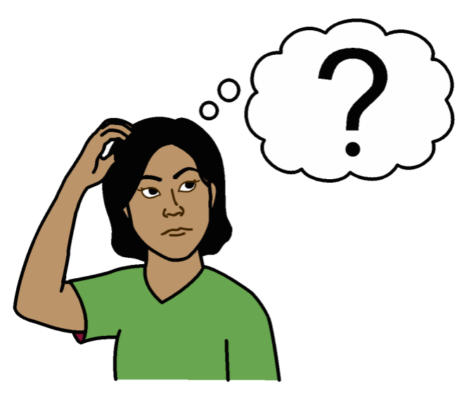
- What children and adults with disabilities might need

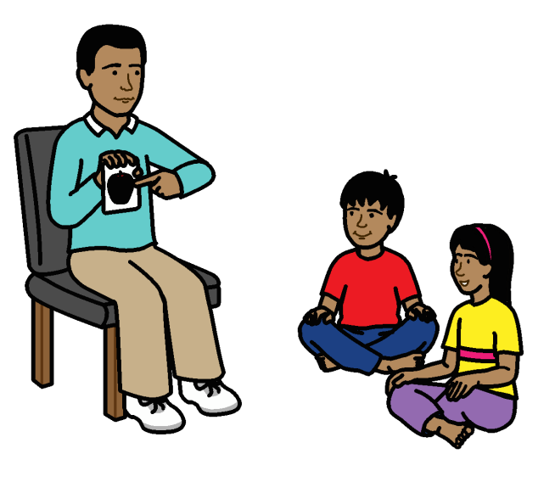
- Why it is important to give people with disabilities information they can understand

- How to give people with disabilities information they can understand

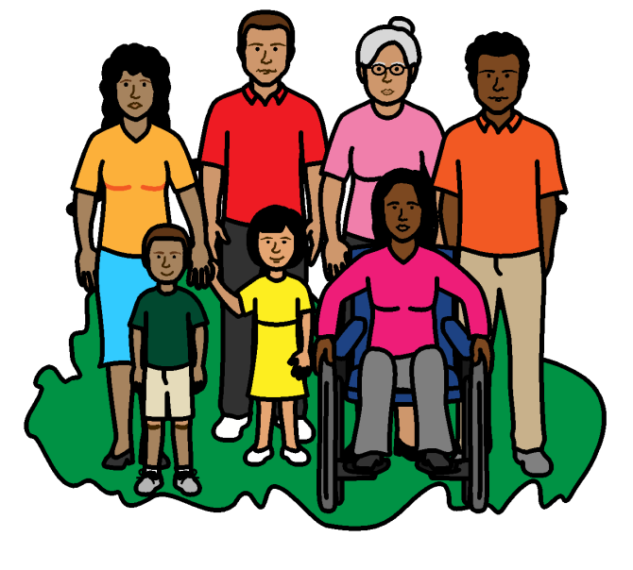

Many people should know about this.

For example, parents, health workers, teachers, support staff and organizations.

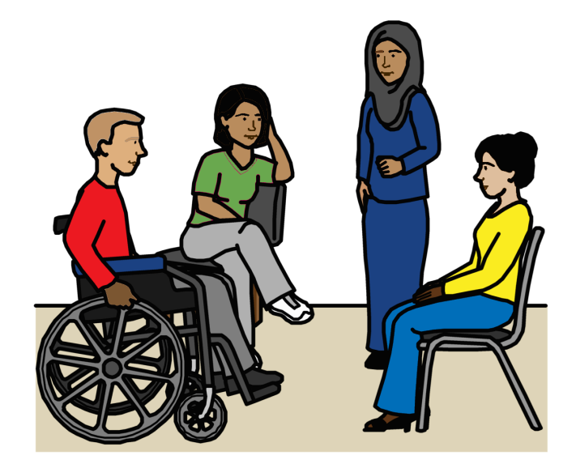
It is important to work with local groups of people with disabilities on plans for Covid-19.

They can give information, advice and training.
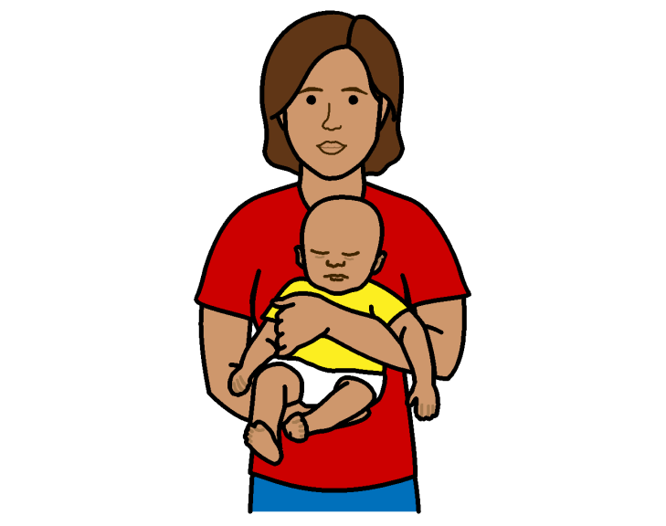

Other people can also help, like:

- Local groups that support people with disabilities

- Groups of parents who have children with disabilities

2.

Find out how to give information to young people with disabilities
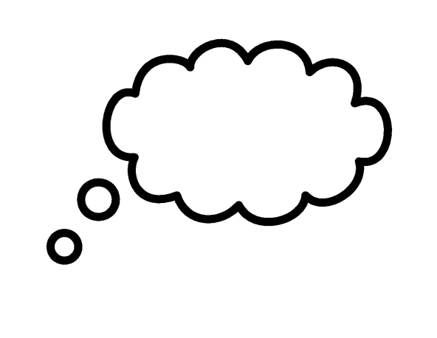
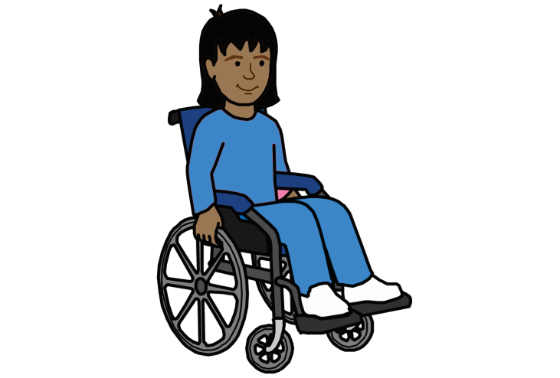
Think about how you want to give people information about Covid-19.
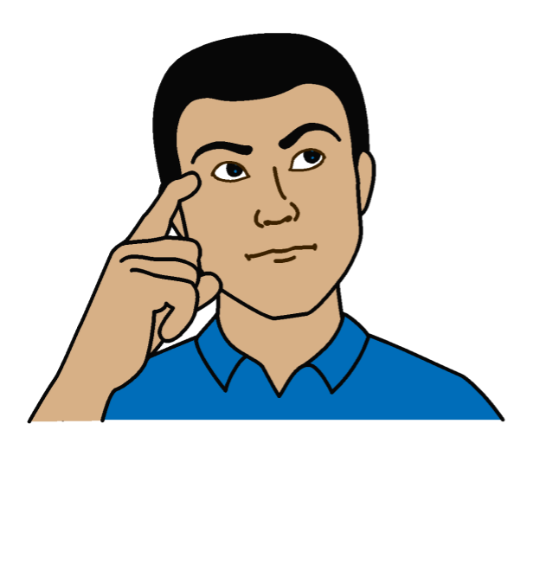

Check if this will work for young people with disabilities.

For example, young people with disabilities who are not at school.

Local groups of people with disabilities can help you know what to do.
3.

Support young people with disabilities to have their say and help change things
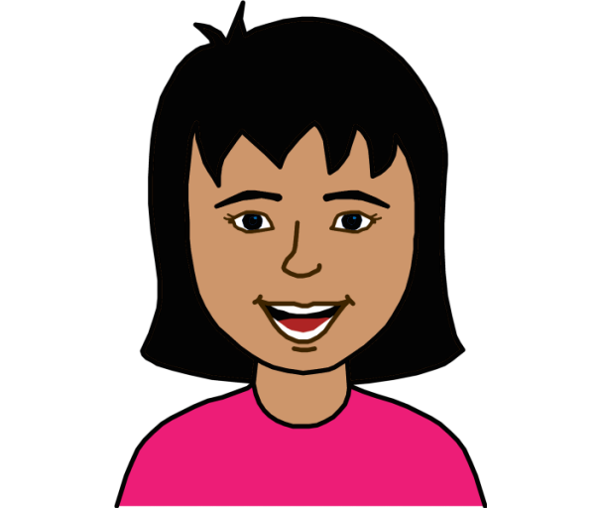

People with disabilities can do important work during Covid-19.

For example, young people with disabilities can:
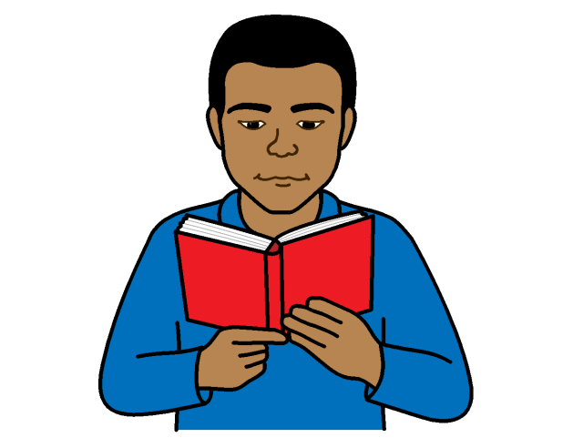

- Help people understand about people with disabilities and what they need

- Make sure people with disabilities get the right information
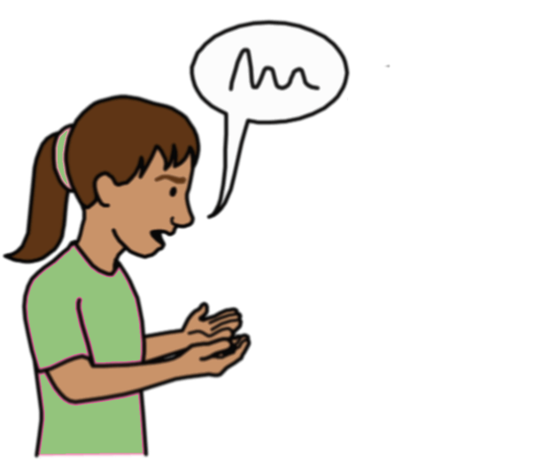

- Change wrong ideas about people with disabilities

- Speak to local TV, radio and newspapers about people with disabilities and Covid-19

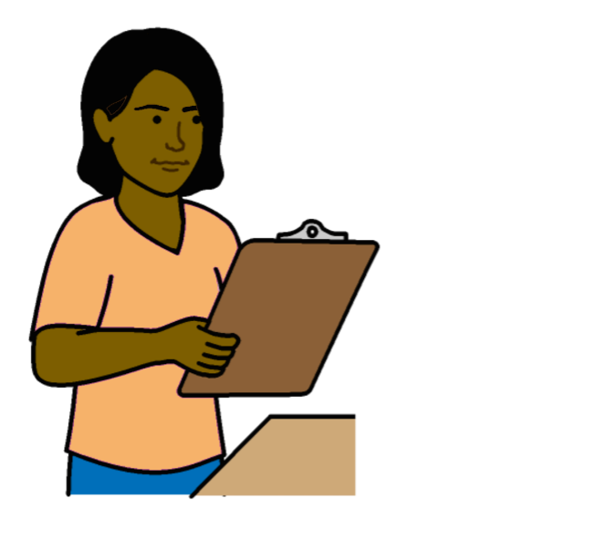
We should:

- Find out how people with disabilities are taking part in plans about Covid 19

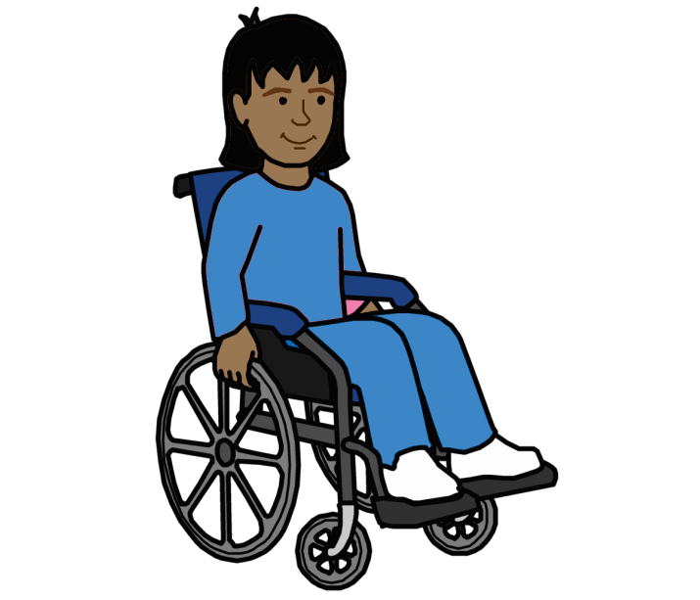
- Solve any problems with them taking part
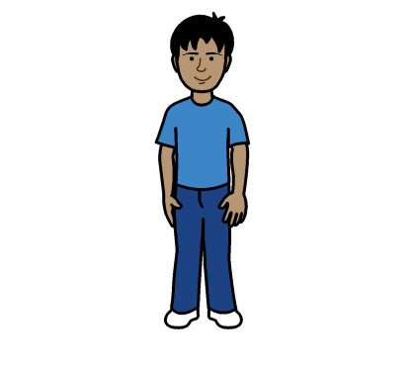

- Find out if local groups of young people are working with young people with disabilities

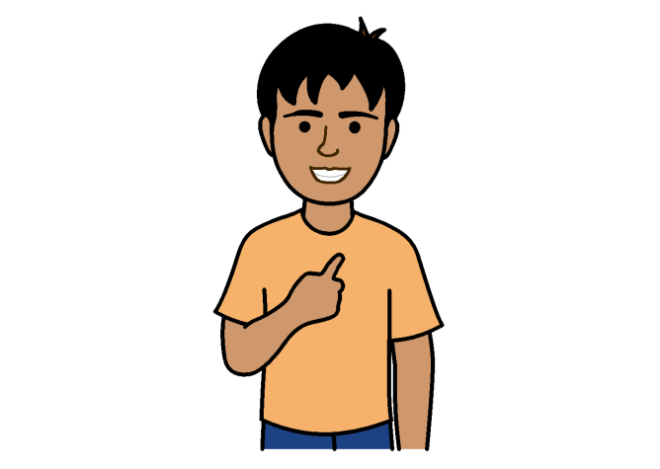
4.

Talk about people with disabilities in the right way

We should talk about the person first. Not their disability.

For example, we should say a child who is deaf. Not a deaf child.
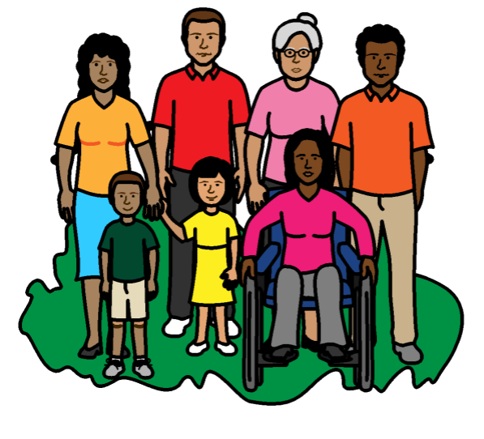

We should use pictures of girls and boys with disabilities when we talk about Covid-19.

This will help people see that people with disabilities are part of the community too.
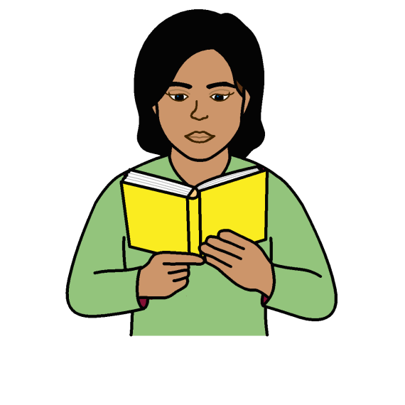
Information for parents about Covid-19 should also talk about children with disabilities.
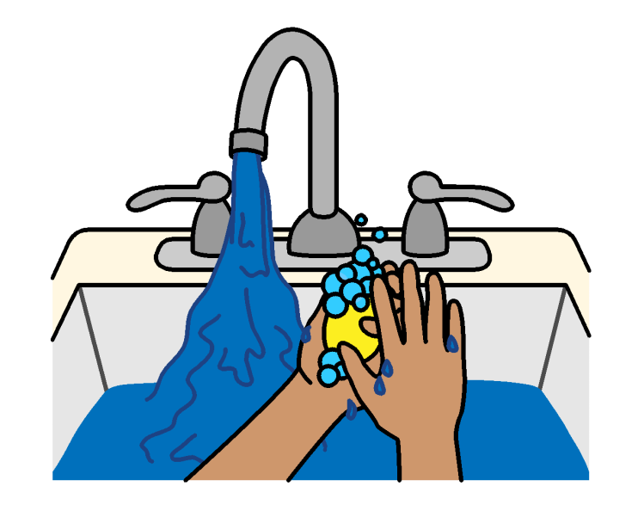

For example, how to help a child who is deaf to wash their hands.

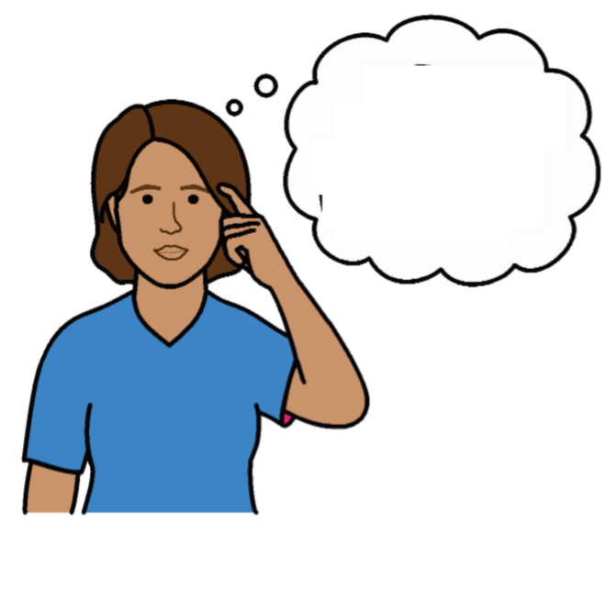
There should be information to show what people think about people with disabilities.

For example, some people may have wrong ideas about people with disabilities and Covid-19.

Pictures by The Picture Communication Symbols ©1981–2016 by Mayer-Johnson LLC a Tobii Dynavox company. All Rights Reserved Worldwide. Thousands of resources available for free at www.boardmakeronline.com
Document checked by Hackney People First.
© European Easy-to-Read Logo: Inclusion Europe. More information at www.easy-to-read.eu.

