How to support children and adults with disabilities during Covid-19

Covid-19 is a new illness that many people in the world are getting. It is also called coronavirus.

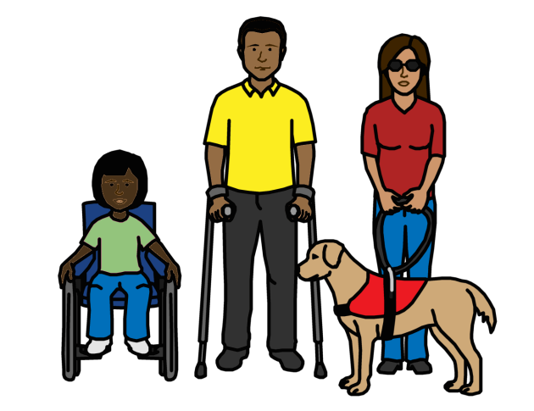

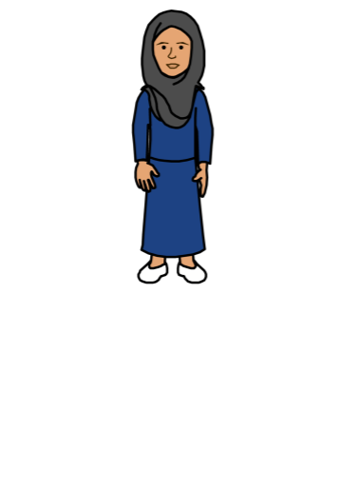

COVID-19 response: Considerations for Children and Adults with Disabilities

About us

We are called Unicef.

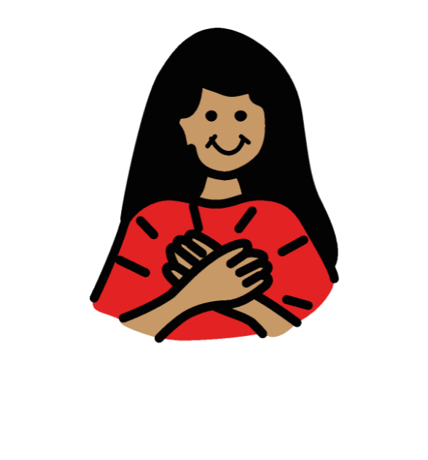

We work to make sure that all children in the world are safe and treated fairly.

About this document

This document is about children and adults with disabilities.

It is about how to support them while Covid-19 is happening.

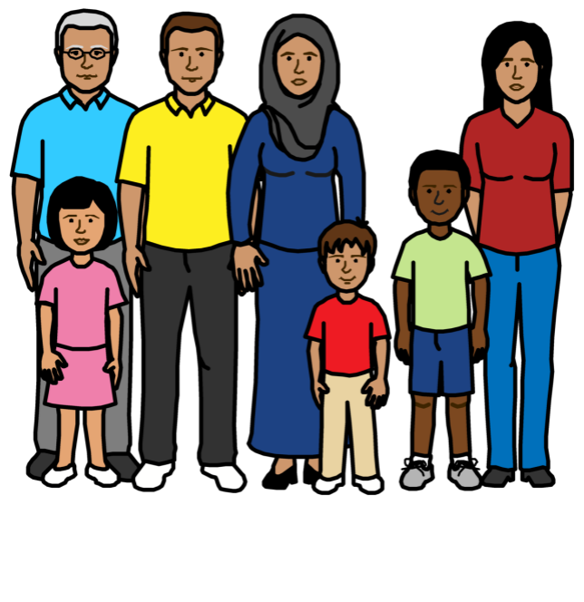
Covid-19 is also called coronavirus.

It is a new illness. Many people in the world are getting it.

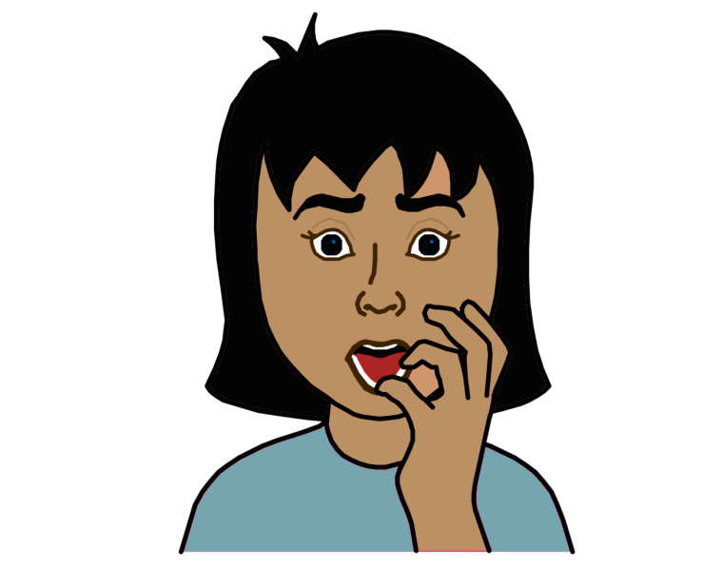

Most people get a bit ill from Covid-19.
Some people get very ill.

Some people with disabilities might be in more danger from this illness.

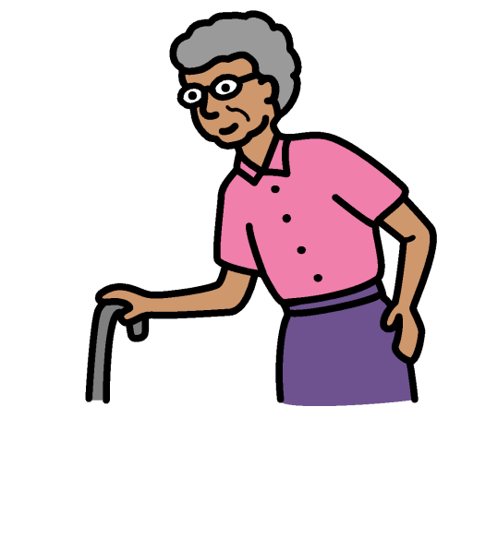
This is because:

- Many people with disabilities are older

- Some people with disabilities already have other health problems

- Many people with disabilities are poor

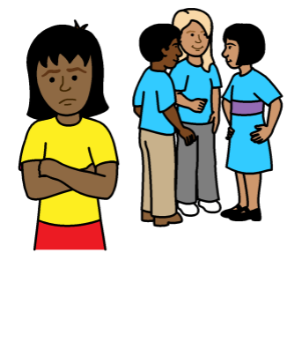
People with disabilities are often left out and treated badly.

This means that people with disabilities may not get the information, health care and support they need at this time.

This document is about what we think should happen to support people with disabilities at the moment.

Anyone can use this information.
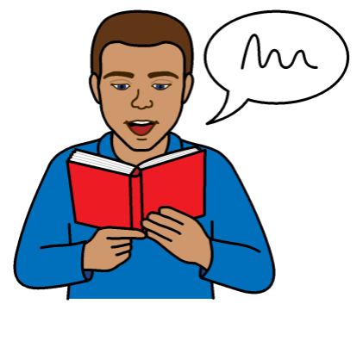
For example:

- People with disabilities and disability groups

- Governments

- People who work for Unicef and other organizations

How to support children and adults with disabilities during Covid-19

1.

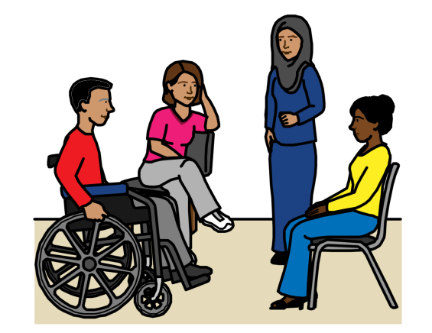
Work with local groups of

people with disabilities straight away

They should have a say in new plans about Covid-19 from the start.

They can also help people know how to support people with disabilities.

2.

Make sure that all people with

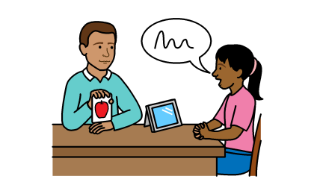
disabilities get the right information about the illness, how to keep safe and where to get support

This means giving people with disabilities information in ways they can understand.

Like easy words and pictures, sign language, video and braille.

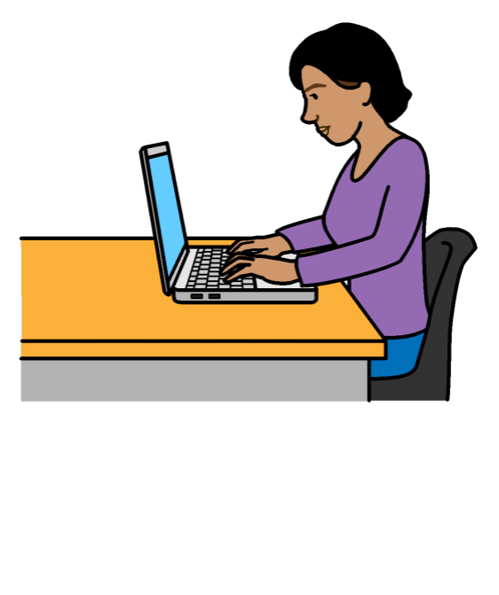
It also means:

- Making websites easy for people with disabilities to use

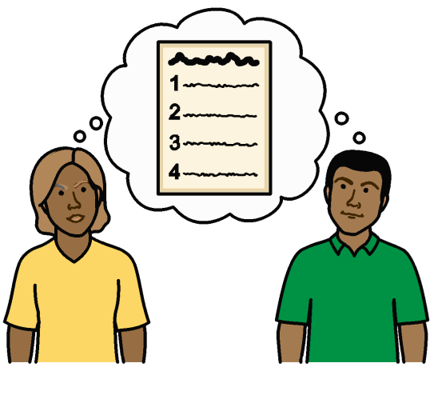
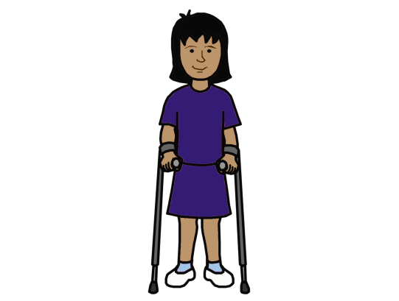
- Finding the best ways to give people with disabilities information

For example, children with disabilities who are not at school

And people who live in hospitals and homes for people with disabilities

3.

Make sure that all people with

disabilities get the health care

they need

For example, by making sure that:

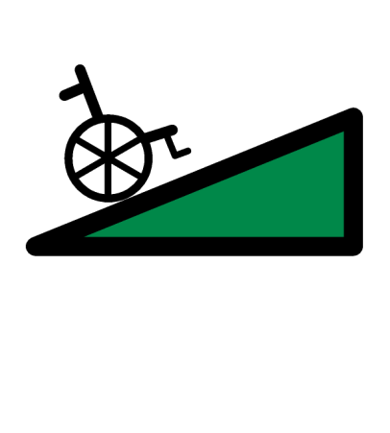
- It is easy for people with disabilities to use transport and get to health places

- Health places are easy to get into and move around in
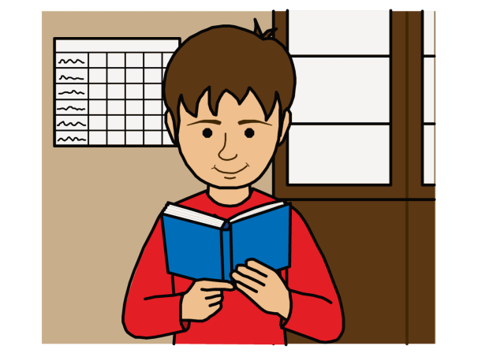
It is also important to make sure that:

- People with disabilities get information they can understand about their health
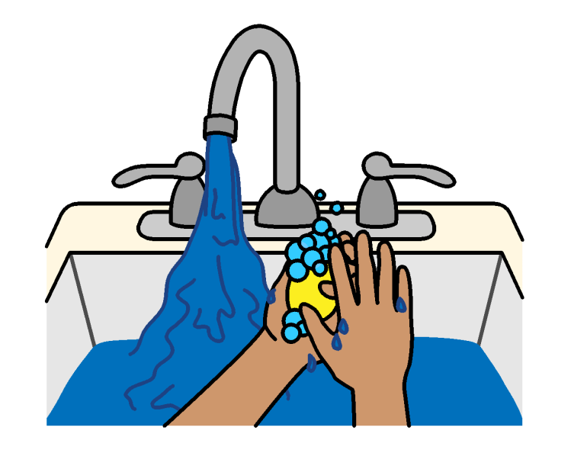

- People with disabilities have the things the need to keep clean at home and in public places

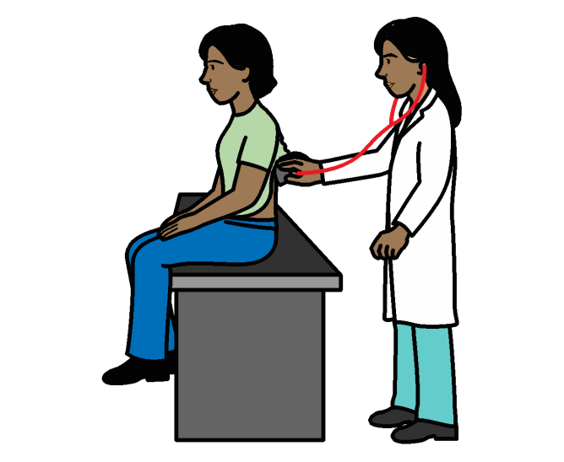

- People with disabilities get the same good health care as everyone else

They should not get worse care because of their disability

4.

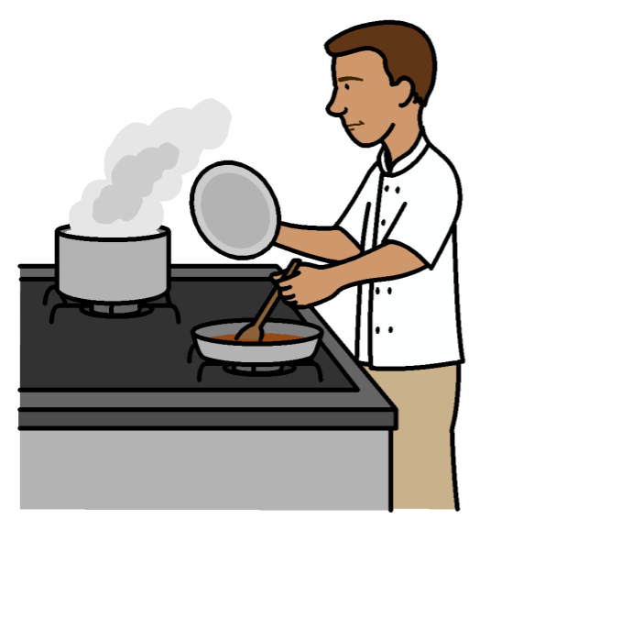
Make sure people with

disabilities still get the support they need

People with disabilities should still get the right support to live at home.

For example, if the people who usually support them get ill and cannot work.
There should be good plans about this.
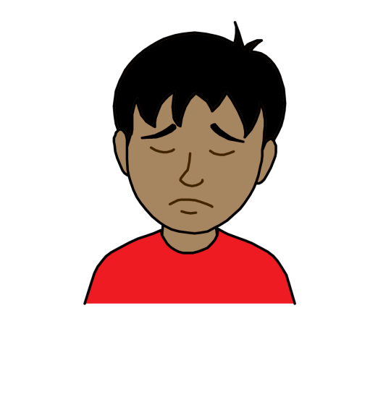
Many people have to stay at home at the moment to stop the illness spreading.

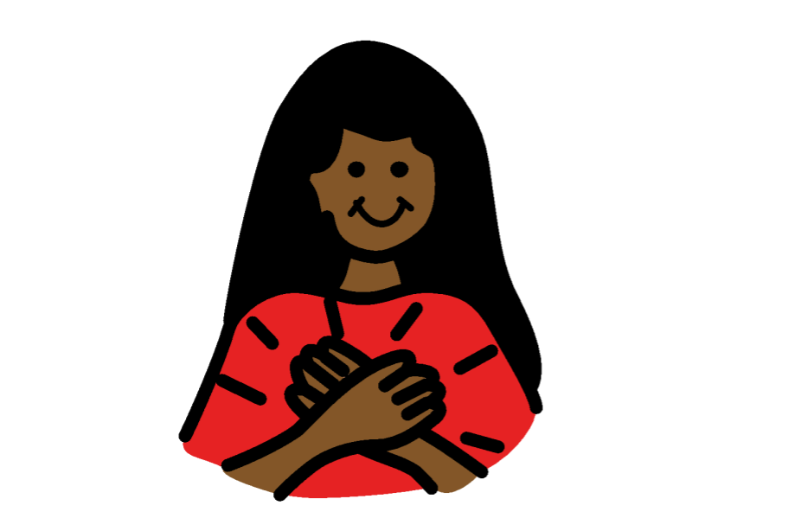

This can be hard for many people.

People with disabilities should get support to cope and feel better if they need it.

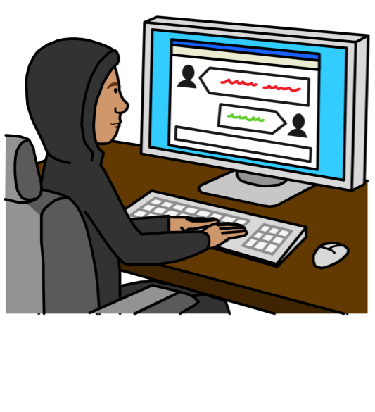

Some schools have closed because of the illness.

We should make sure that children with disabilities can still learn at home and take part in lessons.
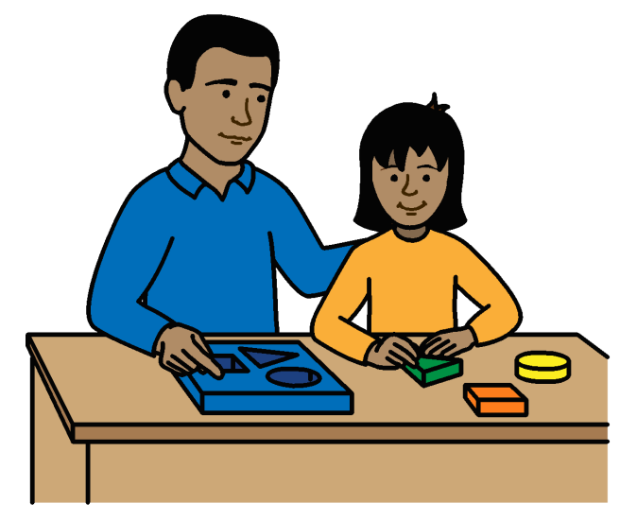

Teachers, parents and carers should get support with this.

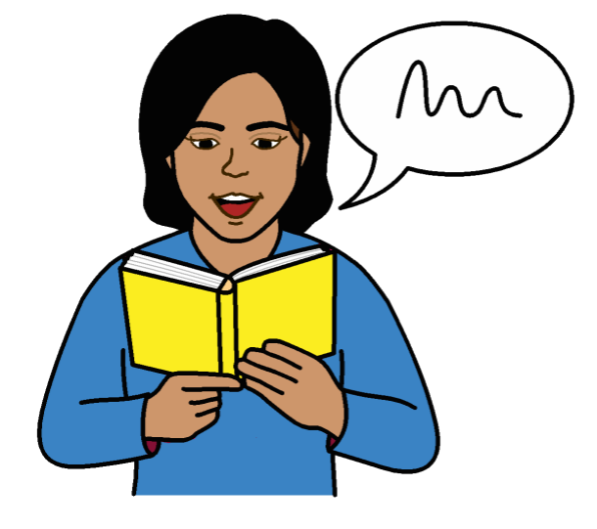
Information for the public about the illness should be fair to people with disabilities.

It should not give people wrong ideas about people with disabilities.
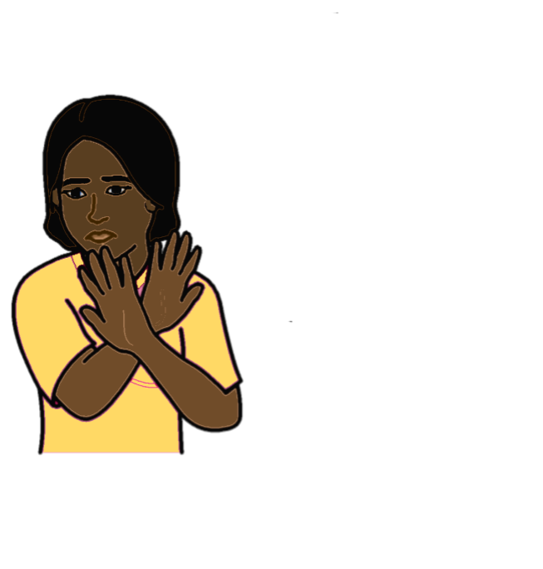

It should be easy for women and girls with disabilities to get support if someone is violent to them.

5.

Make sure there are good plans

to help people with disabilities cope and keep safe
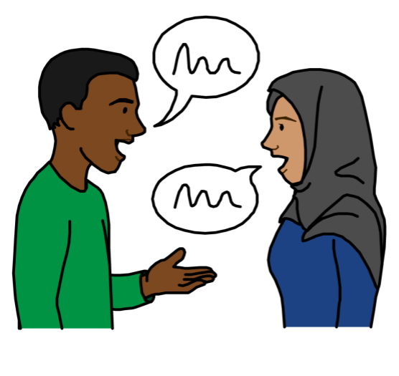

We should start working with groups of people with disabilities straight away to:

- Make plans about this

- Get good information about what is happening for people with disabilities

There are some questions to ask to get information about this. They are called the Washington Group questions

What Unicef should do
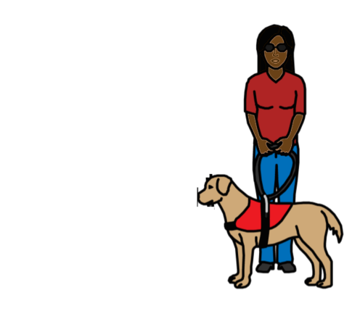
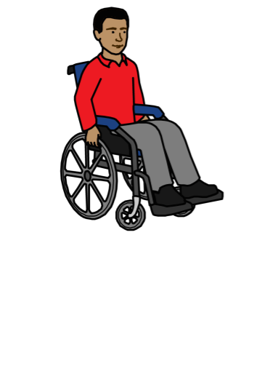

We want to make sure that our staff with disabilities are safe and get the right support at this time.

For example, we can do the following things:

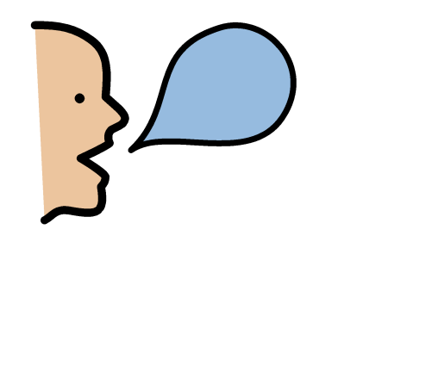
We can make sure all our staff can work from home if they can.

This includes staff with disabilities.

For example, we can use video and other ways to have meetings.

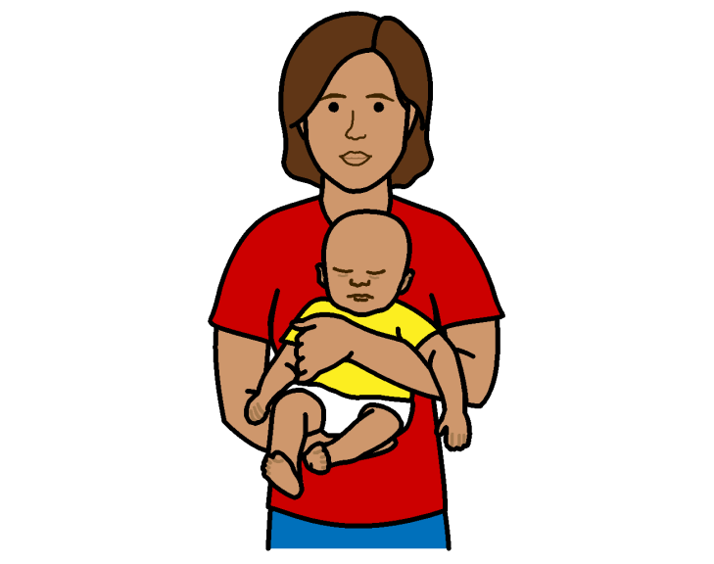

We can make sure that staff with disabilities can change the way they work if they need to.

This includes staff who have children with disabilities.

We can give staff with disabilities useful advice and support.

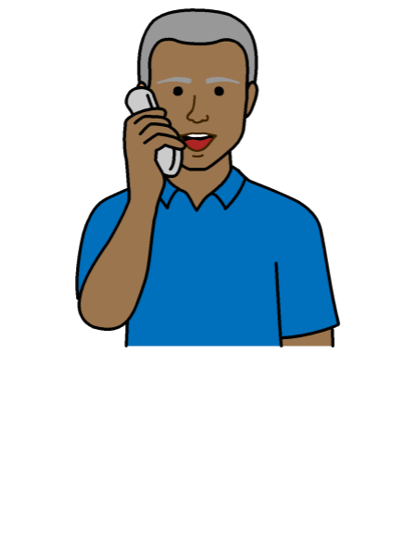
For example, we can:

- Keep in touch more with staff with disabilities to make sure they are OK

- Make sure we give staff with disabilities the same support as before

- Make sure that staff with disabilities can get our mental health support if they need it

Pictures by The Picture Communication Symbols ©1981–2016 by Mayer-Johnson LLC a Tobii Dynavox company. All Rights Reserved Worldwide. Thousands of resources available for free at www.boardmakeronline.com
Document checked by Hackney People First.
© European Easy-to-Read Logo: Inclusion Europe. More information at

